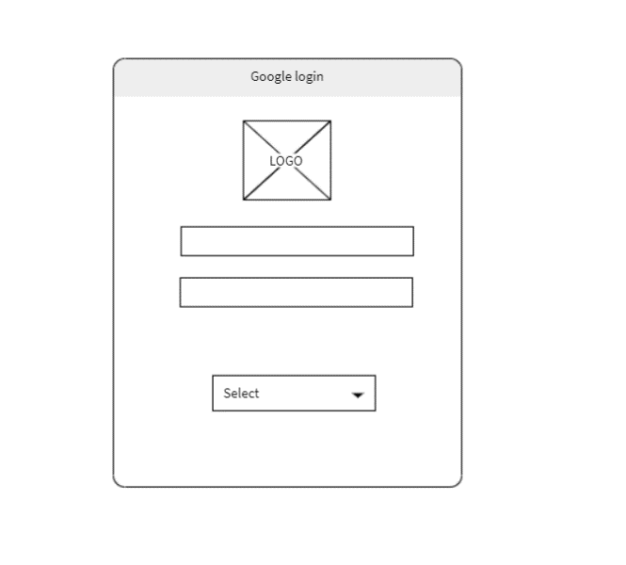

* ***Login page req:***

***1: Student can login with google***

***2: Teacher can login with google***

***(Select dropdown: Select ‘student’ or select ‘teacher’)***

* ***Login as a teacher:***

***I got 3 google emails that are allowed to be teacher (***  
only one of those 3 emails should have access to the teacher page, students should not have permission

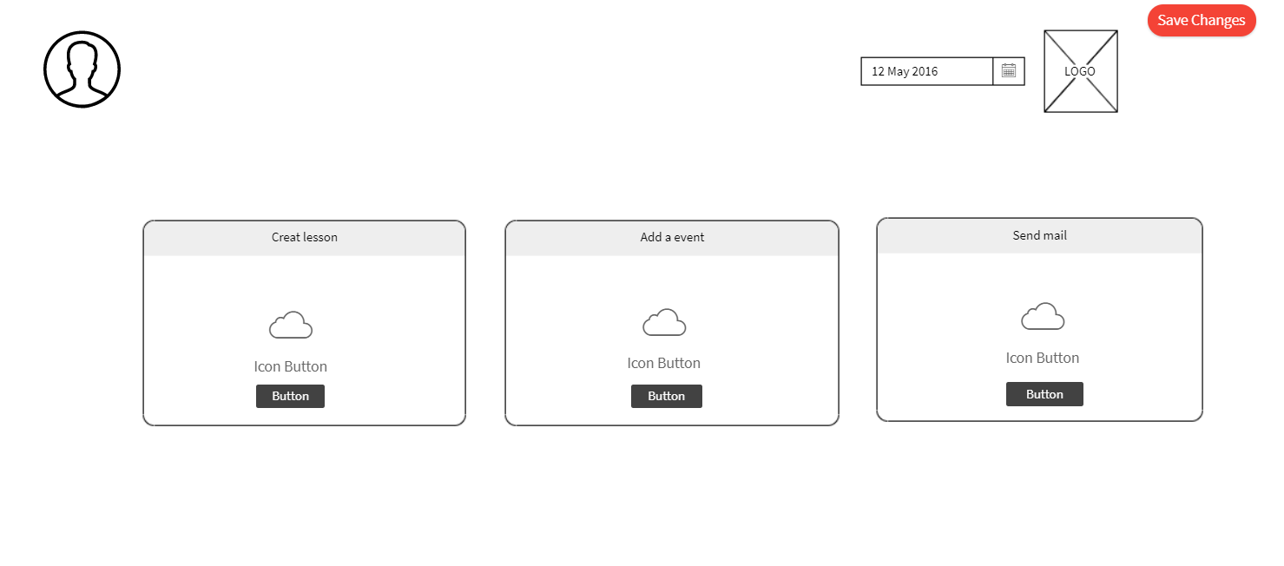

***Teacher create lesson page/another page with: add events***

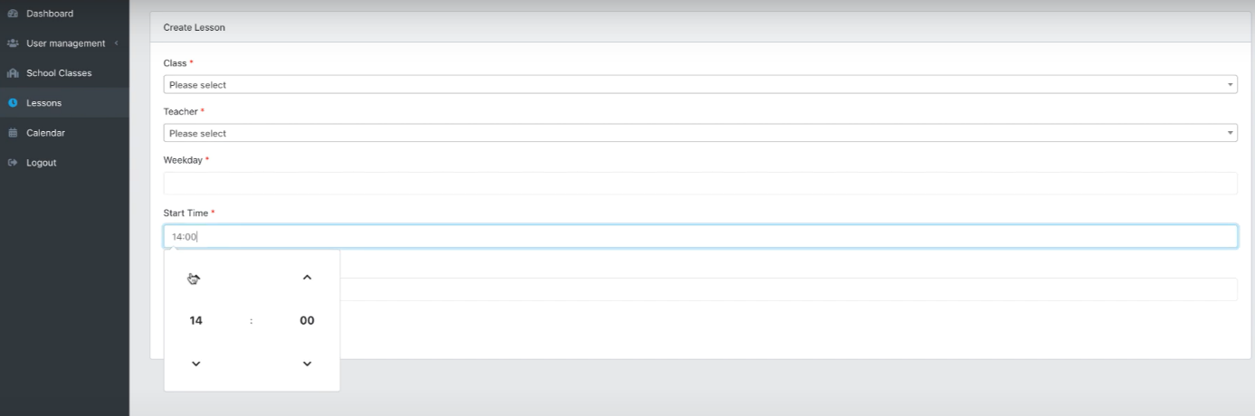

***\*mail page I made one so u can let it emty.***

***And the schedule page needs to be like this***

